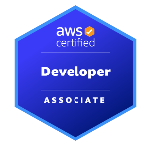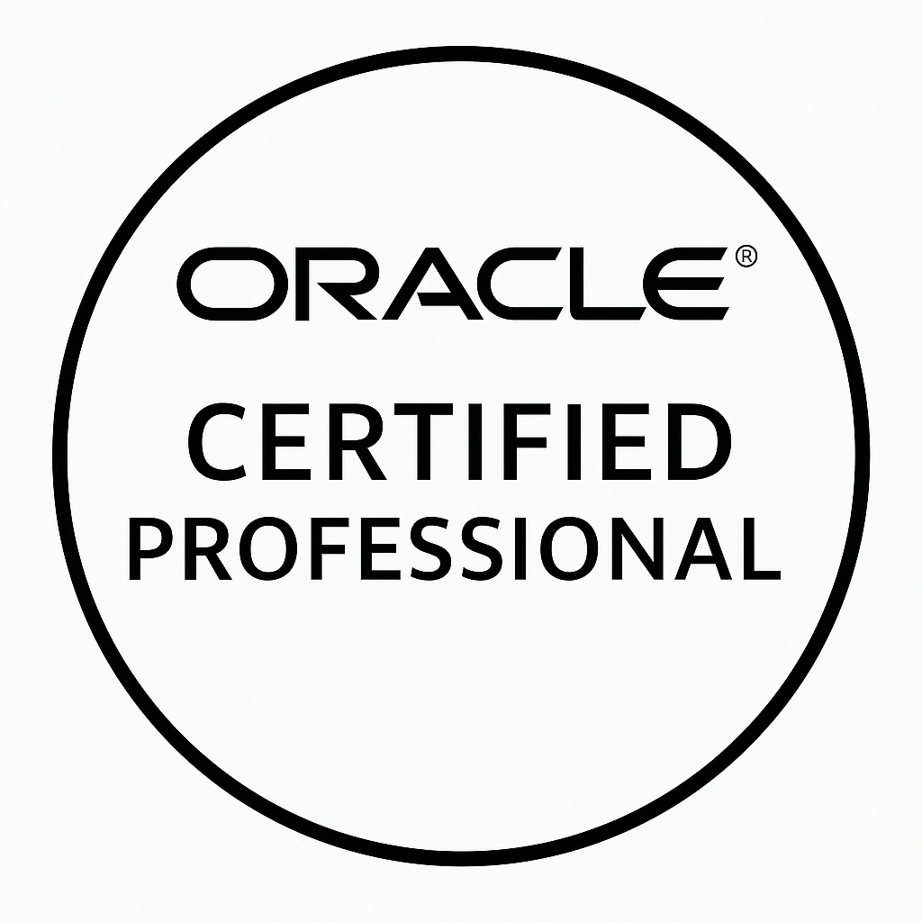
Gopi
Contact :(972)379-7298
Mail id: gopikrishna5lgk@gmail.com

Professional summary:

- Having 9yrs Experience in developing web applications using JSP, Spring Boot, Spring MVC Frameworks, EJB, Hibernate, Spring Security, JBOSS, JDBC, Java Server Pages, Servlet, Web Services, JavaScript, JavaBeans
- Experience with Version Control Systems like Subversion (SVN), Git, and VSS.
- Developed AJAX functionalities using frameworks like JSON, POJO, Ext Js and jQuery.
- Experience in developing applications using Core Java, J2EE, JSP, Servlets, Struts, Spring 3.2, Spring 4.0, Hibernate, Web Services (SOAP, REST), JAX-RS, JAX-WS, JMS, JDBC, XML, JavaScript, Angular4.0, JSON, Ajax and jQuery.
- Expertise in designing and developing Web-centric applications using HTML5, CSS3, Java Applets, JavaScript, XML, JSON, Ajax, jQuery, Bootstrap, AngularJS, NodeJS, ReactJS, Tag Libraries, Google Web Toolkit (GWT) and Custom Tags.
- Performed deployment and support of cloud services including Amazon Web Services (AWS) and Google Cloud Platform (GCP)
- Developed modular and reusable React components integrated with Java backend services to deliver performant, scalable, and user-friendly web interfaces.
- Built dynamic, client-side functionality using modern JavaScript (ES6+), enabling responsive UI interactions and seamless integration with REST APIs.
- Used Python for automation, data processing, and backend utility scripts to streamline workflows and support Java/Spring Boot microservices
- Experience with CI/CD pipelines to integrate the Java code to align with DevOps practices using Docker.
- Built scalable React and Next.js applications with server-side rendering (SSR), static-site generation (SSG), and optimized routing for high-performance web experiences
- Leveraged modern GenAI coding tools such as GitHub Copilot, ChatGPT, and IDE assistants to accelerate development, documentation, code reviews, and refactoring
- Built and consumed GraphQL APIs using Apollo Client/Server, schema-based development, resolvers, and integration into React/Next.js frontends.
- Designed and delivered GraphQL schemas, resolvers, and federated gateways, enabling highly optimized, client-driven data access across distributed microservices.
- Architected scalable NoSQL data models on DynamoDB, optimizing R/W capacity, designing GSIs, and implementing single-table architectures for high-volume transactional systems.
- Developed distributed event-driven microservices using Apache Kafka, implementing producers/consumers,
- Provisioned cloud resources using AWS CDK, managing infrastructure-as-code workflows for CloudFront, Lambda, S3, DynamoDB, and API Gateway
- Expertise in Core Java Such as OOPs, Collections, Exceptions Handling, Input/output (I/O) System, Swing, Annotations, Multi-Threading, Lambda and Generics.
- Expertise in unit-testing with tools like JUnit, Mockito, Spock, TestNG and Integration testing tools like Selenium Web Driver, Cucumber (Behaviour Driven Development testing).
- Hands on experience in developing server-side JavaScript frameworks using Node JS to build event driven, non-blocking i/o model web application
- Experience in integration tools like Spring Integration, Mule ESB, Apache CXF, Apache Kafka and Apache Camel to integrate the enterprise application technologies with existing JVM environment.
- Developed Technical Design (TD), Test Plans (UTP), Test Cases (UTR), Test Scripts for UAT tests
- Proficient in SQL, PL/SQL developed Stored Procedures, Triggers, Functions and Packages besides writing DDL, DML and Transaction queries with development tools like TOAD and Rapid SQL on MySQL, SQL Server and Oracle.
- Experienced in designing NoSQL schemas, building CRUD operations, and implementing aggregation pipelines using MongoDB Java Driver and Spring Data MongoDB with optimized indexing, performance tuning, and high-availability configurations.
- Integrated MongoDB with Java/Spring Boot microservices, leveraging transactions, Change Streams, MongoDB Atlas, and efficient data modeling to support scalable, event-driven, and distributed systems
- Implemented Kafka producer and consumer applications on Kafka cluster setup with help of zookeeper.
- Automated UI regression and functional testing using Selenium WebDriver, Java, TestNG, and Maven, implementing POM, reusable scripts, and reliable element handling with XPath/CSS selectors.
- Integrated Selenium suites into Jenkins CI/CD pipelines, performed cross-browser testing with Selenium Grid, generated execution reports, and collaborated in Agile sprints to validate end-to-end workflows.
- Worked extensively with API Management product of Apigee edge in consuming the API’s in implementing customer use cases.
- Proficient in Java SE6 programming language, with experience in developing and maintaining Java applications
- Deployed Docker contained spring boot Micro services in to AWS EC2 container service using AWS admin console and used lambda to run applications in AWS console.
- Design and implementing Using XML/JSON processing/transforming using Java API’s
- Good Exposure in end-to-end implementation of CI CD (Continuous Delivery), DevOps processes using AWS Code Commit AWS Code Deploy, AWS Code Pipeline, Jenkins, and Ansible.
- Good experience in developing ExtJS applications with extensive server calls using AJAX and strong hold in handling the server data and exceptions to provide interactive user experience
- Expertise in implementing Service Oriented Architecture (SOA) using Micro services, SOAP/RESTful web services and JMS.
- Worked extensively with Waterfall, Agile Extreme Programming (XP), SCRUM Methodologies.
- Excellent analytical, problem solving and interpersonal skills. Ability to learn new concepts fast. Consistent team player with excellent communication skills.

Technical Skills:

Backend
Java 8/11/17, Spring Boot, Spring MVC, Microservices, Hibernate/JPA, Spring Security, REST API
Frontend
Angular, ReactJS, JavaScript, TypeScript, HTML5, CSS3, Bootstrap, Responsive UI
Cloud
AWS (EC2, S3, RDS, Lambda), Azure App Services, CloudWatch, Docker/Kubernetes
DevOps & Tools
Git, GitHub, Jenkins, Maven, Gradle, Docker, Kubernetes, SonarQube, JUnit, Mockito, Swagger, Postman
Databases
Oracle, MySQL, PostgreSQL, MongoDB, Redis
Messaging
Kafka, RabbitMQ
Authentication
OAuth2, JWT, Keycloak

Education:

INDIANA INSTITUTE OF TECHNOLOGY, IN, USA | Master’s in. Software Engineering
Bachelor of Engineering in Computer Engineering

Professional Experience

Client: CITI BANK, CHICAGO Mar 2024 - Present
Role: Java Full stack Developer

Project Description:

A cloud-native onboarding application allowing customers to submit KYC documents, open accounts, complete verification, and track onboarding progress in real time

Responsibilities:

- Followed Agile Software Development Methodology to build the application iteratively and incrementally.
- Participated in scrum related activities and daily scrum meetings.
- Designed dynamic and browser compatible pages using HTML5, CSS3 Pre-processor's (SASS/LESS), Angular 11, Typescript, Bootstrap, JDK, Ajax, Web Services XML, schemas.
- Involved to implement various screens for the front end using Angular and used various predefined components from NPM (Node Package Manager).
- Strong understanding of Java SE6 features, such as scripting support, web services, JDBC 4.0, and GUI improvements.
- Experience with Java SE6 APIs, including Swing, AWT
- Developed UI application initially using Angular 11 and made use of customized components.
- Implemented customer side validations using Angular 11 and created services on UI for storing and retrieving data from UI to the backend
- Upgraded criservice latency under high custome
- Excellent programming skills at a higher level of abstraction using Scala and java
- Execution of tasks in asynchronous mode using multithreading, Executor Service Framework.
- Used JDK, Java Lambda expressions along with Streams for creating internal iteration and performing chain operations such as Filter, Map, Collect on a collection.
- Implemented the function to send and receive AMQP messages on RabbitMQ synchronously and asynchronously and send JMS message to Apache ActiveMQ on the edge device.
- Used spring core for dependency injection/inversion of control (IOC), and integrated with Hibernate.
- Implemented Restful Services in Spring Boot Framework for consuming and producing JSON Data.
- Implemented SOA to develop Spring Restful/Microservices and implemented Spring Eureka, Netflix, Ribbon as part of Services Discovery using Eureka.
- Familiarity with GCP cloud services such as Compute Engine, Cloud Storage, Cloud SQL, App Engine, Cloud Functions, and Cloud Pub/Sub.
- Have knowledge on kotlin Android extensions framework.
- Good Experience in React.js for creating interactive UI's using One-way data flow, Virtual DOM, JSX, React Native concepts.
- Experience with containerization technologies such as Docker and Kubernetes for deploying applications on GCP
- Experienced in working with spark ecosystem using Scala and hive queries on different data formats like text file and parquet
- AWS VPC design and provisioning resources using Terraform and Cloud Formation
- Developed the monolithic application and involved in migrating existing monolithic application in to Micro Service Architecture based RESTful Service and deployments were done on AWS using Spring Cloud for AWS.
- Designed and developed Micro Services business components using Spring Boot.
- Building cloud Microservices and implementing back-up using Spring Boot.
- Used Microservices with Spring Boot services and combination of REST, Apache Kafka messages.
- Worked on custom Docker container images, tagging, pushing images, integration of Spring boot.
- Provided cloud environment for Microservices using spring cloud Netflix (Eureka server).
- Worked in using React JS components, Forms, Events, Keys, Router, Animations and Flux concept
- Used Microservices with Spring Boot services and combination of REST.
- Used AWS SQS to manage message queuing service that makes it easy to decouple and scale Microservices, and server less applications and Communication with External Services.
- Developed web pages using HTML/CSS and Java script
- Good Exposure in end-to-end implementation of CI CD (Continuous Delivery), DevOps processes using AWS Code Commit AWS Code Deploy, AWS Code Pipeline, Jenkins, and Ansible.
- Built event-driven serverless workflows using DynamoDB Streams, Lambda triggers, TTL, and conditional writes, ensuring predictable performance and strong consistency guarantees.
- Built and maintained CI/CD pipelines in GitHub Actions for Java/Spring Boot microservices, automating build, test, security scans, containerization, and multi-environment deployments
- Developed Oracle XML Bamboo Jenkins IIS Chef Puppet PL/SQL Stored Procedures and Queries for Payment release process and authorization process.
- Heavily used joins stored procedures, views, Unions in Oracle database to fetch the data.
- Developed Hibernate with Spring Integration as the data abstraction to interact with the Oracle 11g, implemented transactions, proxies, locking, HQL, Criteria, Projections and Stored Proc calls.
- Kubernetes is configured for automating deployment, scaling and management of containerized applications.
- Used SOAP UI, Postman, Rest Client, Spring Mock MVC, spring 4Junit for testing the web services.
- Used Maven/Nexus as build and dependency management tool for creating EAR, WAR and JAR file to be deployed in application servers and integrated with GITHUB, Jenkins, and Jenkins Jobs.
- Used GIT repository to push the code and interact with other developers throughout the company.
- Used Jenkins CI/CD build server to perform Pull Requests and Dev environment builds.

Environment: Java 11, Spring Boot, Hibernate, JPA, JavaScript, HTML 5.0, CSS3, Angular, Kafka, MongoDB, Bootstrap, Apache Tomcat, Oracle 11g, Log4J, JDK, Easy Mock, XML, Web Services, SOAP UI, Netflix Eureka, Spark, Netflix Ribbon, Maven, Git, Eureka Server, Hystrix, Ribbon, Agile, Spring Cloud Netflix, ELK, GIT, AWS SQS

Client: OPTUM (UHG), MN JAN 2023 – FEB 2024
Role: Java Full stack Developer

Project Description:

- Involved in SDLC Requirements gathering, Analysis, Design, Development, testing production of application using Waterfall model.
- Developed web applications with HTML5, CSS3, Bootstrap and ReactJS.
- Used router to build single page application to navigate through the different status and multiple models.
- Used ReactJS to implement rich functions in various pages: form validation, crud, grid list, search, sort, pagination, multi-selection, tags-input, advanced/custom directives, authentication, unit tests.
- Used ReactJS to create views to hook up models to the DOM and synchronize data with the server as a Single Page Application (SPA).
- Used ReactJS and various predefined Redux libraries for client-side view rendering services.
- Worked on Java 8 features like Lambda expressions, Streams, filters, optional classes and default methods.
- Maintained Interface compatibility and concurrency in the project using Java 8 features like Concurrency API.
- Used Executor Service Interfaces, Thread Pool Executor class for multi-threading & thread resource pooling.
- Developed server-side application to interact with database using Spring Boot.
- Integrated system with healthcare standards like FHIR/HL7.
- Implemented Redis cache to speed up eligibility queries.
- Created asynchronous claim workflows using RabbitMQ event-driven architecture.
- Deployed microservices using Docker and Azure App Services.
- Improved code quality with JUnit, Mockito, and automated integration tests.
- Used ELK stack for centralized logging and monitoring
- Environment: Spring Boot, React, RabbitMQ, PostgreSQL, Azure App Services, Redis, Docker

Client: Techno Endeavors, Hyderabad Aug 2018 – Feb 2021
Role: Java Full stack Developer

Project Description:

- Hands on experience in Web Application Development using Client Script design technologies like jQuery as well as HTML, CSS, XML, Java Script.
- Involved in coding front-end components using J2EE, MVC, JSP, JSF, jQuery, and AJAX.
- Worked on core java and java Collections concepts to implement the business logic.
- Designed, developed, and configured server side J2EE components like EJB, Java Beans, and Servlets.
- Wrote EJB POJOS for fetching patient SDE information.
- Designed and Developed java batches using spring batch framework.
- Extensive experience in Struts Tag Libraries and Custom-tag implementations in JSP to embedded business logic.
- Optimized the design using patterns like DAO, Factory, Singleton, Service Locator and Business Delegate. All code was written using the RAD.
- Mapped POJO (plain old java objects) to the tables already created in the database using the *. Hbm.xml files.
- Designed and Developed Web Services using WSDL, SOAP to communicate to the other modules and used SOAP UI for testing the web services.
- Used Grunt for build tool for configuring tasks, Karma Jasmine for Unit Testing and deployed application on to JBoss application server.
- Wrote stored procedures, complex queries using PL/SQL to extract data from the database, delete data and reload data on Oracle 10g database using the Toad tool.
- Involved in Junit Testing on various modules by generating the Test Cases Involved in building and deploying projects using Hudson and do end-to-end testing.
- Used CVS as a version control for applications.

Environment: Spring MVC, Hibernate, AngularJS/Angular 2, Oracle, Jenkins, REST APIs

Client: ACS Technologies, Hyderabad Jun 2015 – Aug 2018
Role: Java Full stack Developer

Project Description:

- Involved in various phases of Software Development Life Cycle (SDLC).
- Used Apache POI to generate CSV reports.
- Used Collection Framework and Multithreading for performance improvement.
- Proven experience with Application Servers like Tomcat.
- Integrated with Alfresco using API for document management and versioning.
- Designed and developed the UI using JSF and Rich Faces view components HTML 5, CSS 3, JSP, and JavaScript & JSON.
- Used Maven for compilation, building JAR & WAR files & Used Log4j utility to generate logs.
- Designing, Development, JUnit testing of many components of the applications from end-to-end.

Environment: Java, JSP, Servlet, jQuery, JDBC, MySQL, Git

